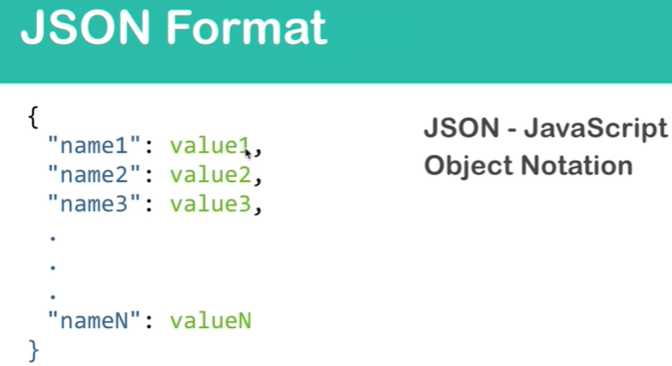

**JSON:** JavaScript Object Notation.

1. A standard format.
2. It was developed in 2001 and became standardized in 2013.
3. Json is key-value pairs.
4. Each key must be in double quotations.
5. Each value is of certain data type.
6. There are 6 data types in JSON.
7. 